Hydraulics of the lagoon system

The hydraulic behavior of the PILS (Figure 2) is strongly influenced by tidal fluctuations and by the geomorphological constraints imposed by its connecting channels and tidal inlets. During flood tide conditions, sea level rise promotes marine water inflow through the Itaipu Channel and, to a lesser extent, through the Tibau Tunnel, increasing water levels within both lagoons. During ebb tide periods, drainage from the lagoon system toward the ocean occurs, although this process is partially restricted by channel geometry, sedimentation processes, and hydraulic controls. These oscillations play a fundamental role in the system’s hydrodynamic balance, directly influencing circulation patterns, water renewal efficiency, and water quality conditions within the lagoons.
A particularly important hydraulic feature of the system is the sill located at the lagoon outlet of the Tibau Tunnel, which acts as a hydraulic control regulating the minimum water level in the Piratininga Lagoon. Due to the limited hydraulic efficiency of the Camboatá Channel in connecting both lagoons, the sill prevents excessive drainage of the Piratininga Lagoon during low tide periods, maintaining a permanent water column and reducing exposure of bottom sediments. Historically, episodes of extremely low water levels have resulted in sediment exposure, unpleasant odor emissions, and deterioration of environmental and sanitary conditions in surrounding urbanized areas. Consequently, the sill plays an important role not only in hydrodynamic regulation, but also in maintaining environmental stability and mitigating degradation processes associated with prolonged stagnation and sediment exposure.
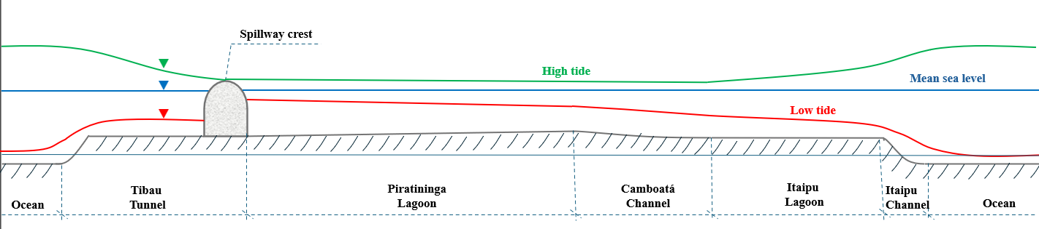
Figure 2 - Schematic longitudinal slice of the PILS, showing hydraulic behavior during high and low tide conditions. The diagram illustrates the influence of the Tibau Tunnel spillway crest, which limits the minimum water levels in Piratininga Lagoon, preventing the exposure of the lagoon bed and maintaining a stable water volume throughout tidal

